Analytical report on the results of the complete accounting of snow leopard in Russia in 2022.

At the initiative of the World Wide Fund for Nature (WWF Russia) and with the financial support of the Foundation «World Around You» Corporation «Siberian Wellness», Xiaomi company, as well as WWF supporters in February-April 2022, the number of snow leopard (irbis) was counted in the territory of 3 constituent entities of the Russian Federation: in the republics of Altai, Tyva and Buryatia.
A total of 82 people from 12 organizations participated in the works.
4 organizations were involved in accounting in the Republic of Altai: FSBI «National Park «Sailugemsky», FSBI «Altai State Natural Biosphere Reserve» The State Committee for Protection of Animal World Objects of the Republic of Altai and the Directorate of Specially Protected Natural Territories of the Republic of Altai (employees of four natural parks participated: «Zone of Rest Ukok», «Ak-Cholushpa», «Belukha» and «Uch-Enmek»), as well as the Voluntary Expedition «In the footsteps of a snow leopard». Routes were laid on the ridges: Severo-Chui, Yuzhno-Chui, Katunsky, Kurai, Sailugem, South Altai. On the ridge of Chikhacheva (from the Altai side) accounting work could not be carried out due to difficulties in providing logistics in this area.
In the Republic of Tyva, five organizations were involved in accounting work: The State Biosphere Reserve "Ubsunur Hollow", the State Committee for the Protection of Wildlife of the Tyva Republic, the Natural Park "Tyva", the Directorate of Specially Protected Natural Areas of the Tyva Republic, and the World Wide Fund for Nature. The routes were laid along the following ranges: Chikhacheva, Mongun-Taiga, Tsagan-Shibetu, Shapshalsky, Kurtushibinsky, Hemchiksky, Western Tannu-Ola.
In the Republic of Buryatia, two organizations were involved in the accounting work: FSBI "Tunkinsky National Park" and the Regional Public Organization "Asia-Irbis". The research covered the following ranges: Bolshoi Sayan, Munku-Sardyk, Kitoy and Tunkin mountains (Fig. 1).
All accounting activities were conducted in accordance with the methodological recommendations for the monitoring of the snow leopard population in the Russian Federation (approved by Order of the Ministry of Nature of Russia № 39-r of 04.10.2021 "On approval of Methodological recommendations for organizing and conducting monitoring of the snow leopard") with completion of all accounting forms in a specialized mobile application NextGIS Collector. When traces of irbis activity were detected, trails were traced until excrement was detected, if possible. The excrement samples collected were submitted to the Institute of Ecology and Evolution of the Russian Academy of Sciences for further molecular-genetic identification of the specimens.
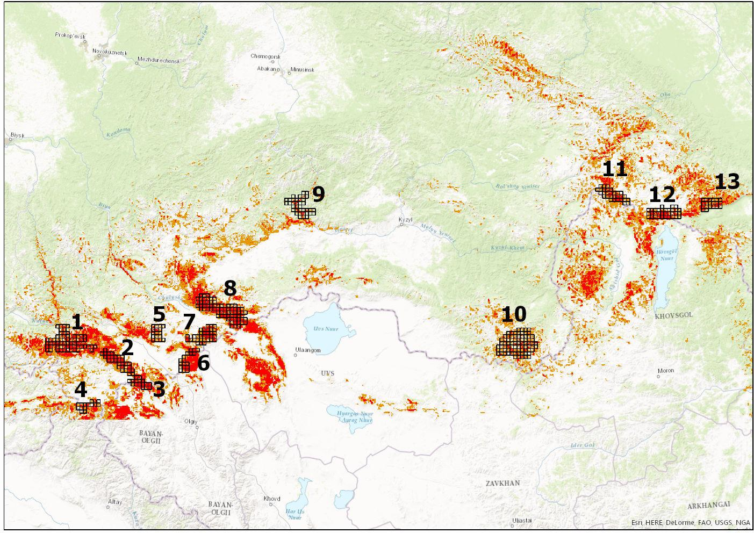
Fig 1. Location of monitoring sites.

Republic of Altai.
Chikhachev Ridge (Altai part, site no. 6 in Fig. 1). It was not possible to carry out accounting work in the winter of 2022. Two adults were counted from the Tuva side of the ridge, including Khorgai, previously regularly recorded in the Altai Republic (see below).
The Kuraisky Ridge (section 5 in Fig. 1). Three adult snow leopards were recorded here based on footprints in the snow and photo-trap footage.
Sailugem Ridge (site №3 on fig. 1). Eight individuals of the snow leopard, including 5 adults and 3 kittens were recorded on camera traps installed in the territory of the "Sailugemsky" National Park.
The Argut River basin (site No.1 in Fig. 1). In total 19-20 individuals were recorded including 15-16 adults and 4 kittens in 2 broods.
South-Chuyskiy Ridge (site 2 on Fig. 1). In total 13 individuals were observed, including 8 adults and 5 kittens in 2 broods.
Ukok Plateau (South Altai, site 4 in Fig. 1). The presence of snow leopards was not registered by camera traps installed in the territory of the "Resting area of the Ukok" Nature Park. Due to bad weather conditions, it was not possible to carry out the work in full.
The total number of irbis in the Republic of Altai observed in 2022 was 43-44 individuals, including 31-32 adults and 12 kittens in 5 broods. This is the minimum estimated number of snow leopards and does not equate to the total snow leopard population in the area.

Tuva Republic.
Chikhachev Ridge (Tuvinian part, section no. 6 in Fig. 1). In the southern part of Chikhachev Ridge Two adult snow leopards, including the oldest individual in Russia (age no less than 12-13 years) - male Horgai, usually inhabiting the adjacent territory of the Altai Republic, were marked by camera traps.
The Mongun-Taiga massif (site 7 in Fig. 1). The presence of two adult snow leopards was recorded on the tracks.
Tsagan-Shibetu Ridge (site №8 on fig. 1). According to photomonitoring data the presence of 10 individuals of snow leopard, including 7 adults and 3 kittens in 2 broods was recorded.
Shapshal Ridge (site No.8 in Fig.1, is a continuation of the Tsagan-Shibetu Ridge). According to photomonitoring data and traces of life, 5 individuals of snow leopards were counted, including 4 adults and 1 kitten.
Kurtushibinsky and Hemchiksky Ridges (previously the area was not identified separately, it adjoins the area No. 9 along its southern boundary). Earlier in the specified area the irbis was not registered, more than 30 years ago there was no reliable information about the habitation of the snow leopard in this area. In 2022 two or three adults were counted during the census (one is still under question).
Western Tannu-Ola (previously the area was not identified and was considered only as potential habitat for the snow leopard, located to the north of the Ubsunur Lake along the state border). Three adult snow leopards were tracked.
The total number of irbis in the Tuva Republic in 2022 was 24-25, including 20-21 adults and 4 kittens in 3 broods.

During the winter counts in the Eastern Sayan (plots No. 11-13 in Fig. 1) 4 adult irbis and 2 kittens in one brood were recorded. Thus, the number of irbis in the Republic of Buryatia is estimated to be a minimum of 6 individuals.

CONCLUSION
The minimum number of snow leopards observed in the monitored area, which is approximately 80% of the species' habitat in Russia, is estimated at 73-75 individuals (55-57 adults and 18 kittens). A total of 9 broods of snow leopards were reliably recorded.
Also, according to the information provided by the management of the FSBI "Sayano-Shushensky State Nature Biosphere Reserve'' (letter № 199 from 20.05.22, see Appendix), there are 6 individuals of snow leopard on their territory, including 2 individuals, which were counted in the cluster area "Shanchy" Republican State Budgetary Institution "Tyva Nature Park". However, due to the lack of primary information on the distribution of snow leopards in the reserve (absence of tracks and sighting points, materials on individual identification of individuals, etc.), this information is not included in the overall assessment of the number of snow leopards in the Russian Federation.
Compared to 2019-2020 there is an increase in the presence of the snow leopard, primarily due to the group species in the basin of the river. Argut, the South Chuisky and Saylyugemsky ridges - that is, on the territory of the Saylyugemsky National Park and significant areas (including the Uch-Enmek Park and the Shavlinsky Order). However, it should be noted that the Yuzhno-Chuysky massif throughout its entire length is a public hunting ground, therefore, in order to collect snow leopards in the Altai Republic, it is necessary to significantly strengthen the protection of this area.
A group of snow leopards on the Chikhachev Ridge, which is also present everywhere within the Altai Republic as public lands, causes serious concern. Unfortunately, in 2021, during the planned registration of camera traps, there were only 2 individuals here, although earlier, for almost 10 years, 5–8 individuals were measured annually. Considering the exclusion of a serious Chikhachev Ridge for meeting the snow leopard in Russia (this is a forced corridor between the Russian part of the Altai-Sayan population of the species and its return to Mongolia), urgent measures are needed, first of all, the creation of a buffer zone of the Altai Reserve on the Altai macroslope of the ridge.
The situation with the snow leopard on the Ukok Plateau is not completely clear. Due to the abnormal temperature and heavy snow, it was not possible to check the cameras installed along the mountain ridges here, so we can say with confidence about the underestimation in this area.
In the control of Tyva, in general, all groupings are stable; on the Tsagan-Shibetu ridge, there is a lack of high rates of population growth. The most interesting and important fact is the fact that for 30 years the snow leopard has been identified on the Kurtushibinsky and Khemchiksky ridges, in accordance with the administrative borders of the Republic of Tyva and the Krasnoyarsk Territory. a good condition of the forage base has been chosen on a specialized site, there is a chance to get a group of snow leopards here, for which we will seriously strengthen the control of the territory (the Khan-Deer cluster site of the Ubsunur Hollow Reserve, the Shanchy cluster site near the Tyva park and the coastal reserve " Buura"). Also, for the first time, reliable information was obtained about the habitation of the snow leopard on the Western Tannu-Ola ridge, on which no previous surveys were carried out.
A serious fear of an uprising is also the state of the snow leopard group in the Eastern Sayan. For the first time in 10 years of research in the field of work accounting, there was no meeting of a single Siberian ibex, during this period a steady upward trend in population and the extinction of rare foci of the disease was noted. In connection with this and the preservation of the snow leopard in relation to Buryatia, it is under great specificity. Extremely important is the special protected natural area created in the place of the snow leopard settlement in the Okinsky district of the Republic of Buryatia. Unfortunately, on the territory of the Tunkinsky National Park there is only 10% of the habitats of the species in the field of prey, while the prey of the Eastern Sayan group of snow leopards is located precisely in the Okinsky district of the republic.

